Noeleen Lesley Bates

17/6/1932 – 10/6/2023

“Your Mother Is Always With You”

She’s the whisper of the leaves as you walk down the street,
She’s the smell of certain foods you remember,
flowers you pick, the fragrance of life itself.
She’s the cool hand on your brow when you’re not feeling well,
She’s your breath in the air on a cold winter’s day.
She is the sound of the rain that lulls you to sleep, the colours of a rainbow.
She is the Christmas morning.
Your mother lives inside your laughter.
She’s the place you come from, your first home.
She’s the map you follow with every step you take.
She’s your first love, your first friend, even your first enemy.
But nothing on Earth can separate you,
Not time, not space, not even death.
By Debora R Culver
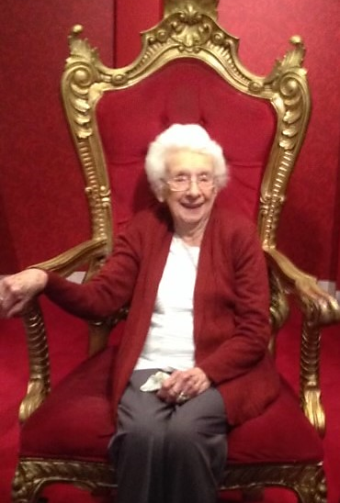

ORDER OF SERVICE

Music – Supermarket Flowers (Ed Sheeran)

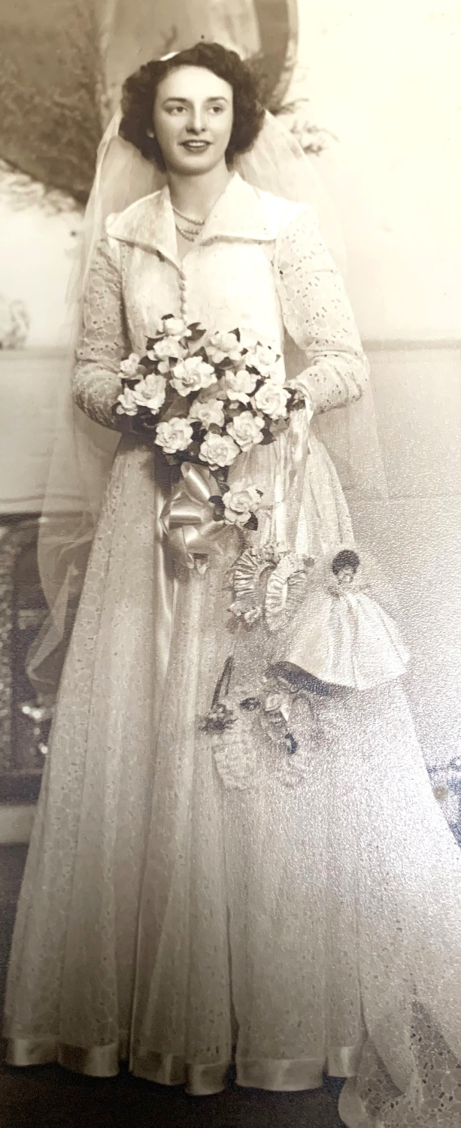
Poem – Your Mother Is Always With You

Welcome – Helen Trigg (Celebrant)

Candle Lighting – You’ll Never Walk Alone (Jim Nabors)

Eulogy – Helen Trigg

Family Tributes – Leanne
Deidre
Rachel & Kelly

Photo Presentation – Medals For Mother (Daniel O’Donnell)
- Somewhere Over The Rainbow (Israel Kamakawiwo’ole)

Committal

The Lord’s Prayer

Music – The Prayer (Anthony Callea)

Noeline will be privately cremated.

Noeleen’s family would like to thank you for
your kind thoughts and prayers at this time.

Following the service, they invite you to join
them for refreshments at Leanne’s home –
4 Amarina Road, Clifton Springs.

