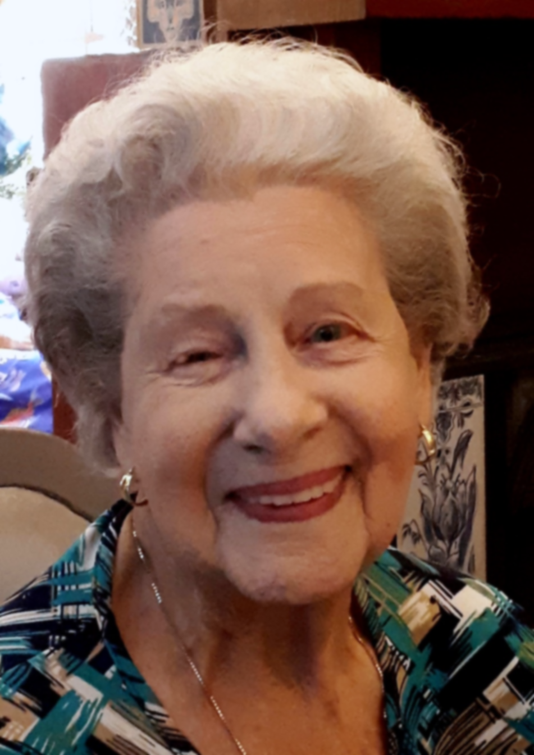

Celebrating the Life of

Hazel Nicholls

4/8/1929 – 5/6/2023

We are the Old-world people.
Ours were the hearts to dare;
But our youth is spent,
and our backs are bent,
And the snow is in our hair.

ORDER OF SERVICE

Music: “Just A Closer Walk With Thee” (BJ Thomas)

Poem:

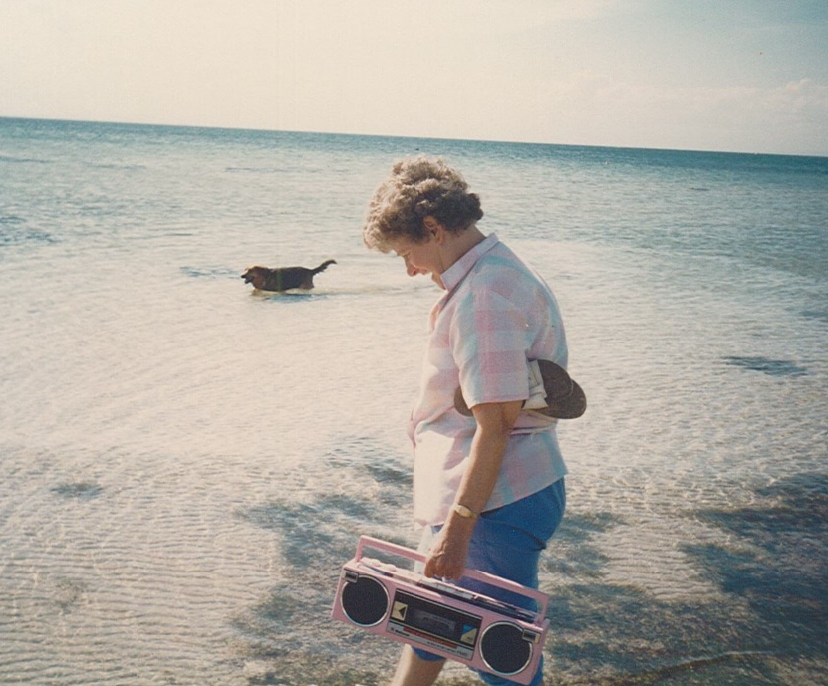
Welcome: Helen Trigg – Celebrant

Eulogy:

Photo Presentation:
“I Believe” (Frankie Laine)
“Holy City” (David Hobson)

Committal:

23rd Psalm:

The Lord’s Prayer:
Our Father who art in heaven,
hallowed be Thy name,
Thy kingdom come,
Thy will be done, on earth as it is in heaven,
give us this day our daily bread
and forgive us our trespasses
as we forgive those who trespass against us
and lead us not into temptation,
but deliver us from evil,
for Thine is the kingdom, the power and the glory,
now and forever, Amen.

Music: “We’ll Meet Again” (Vera Lynn)

Hazel will be privately cremated.
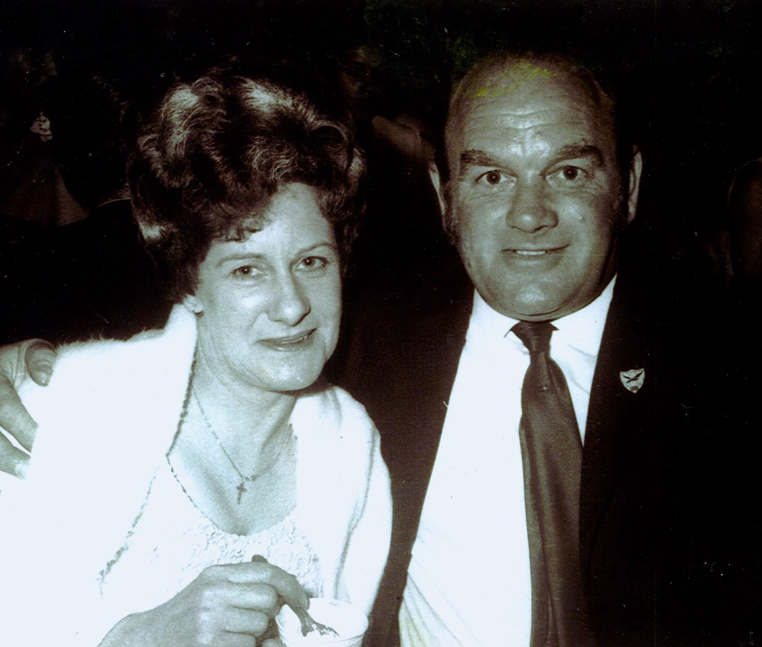

Hazel’s family would like to thank you sincerely for
all your kind thoughts and prayers at this time.

Following the service, the family invite you to join
them for refreshments at the Drysdale Bowling Club.

